42.44: a) The frequency is proportional to the reciprocal of the square root of the reduced mass, and in terms of the atomic masses, the frequency of the isotope with the deuterium atom is
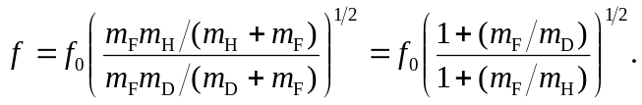
Using 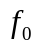from Exercise (42.13) and the given masses, 